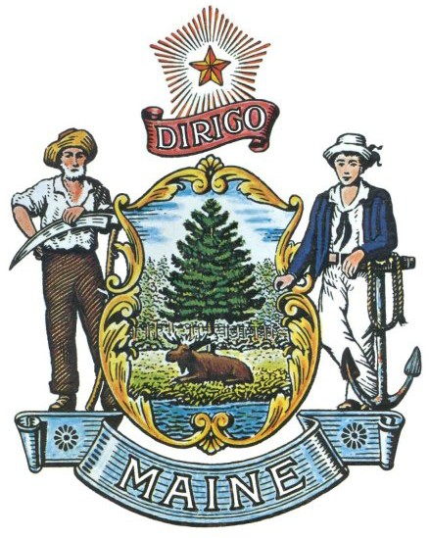
CHRISTINE MUNROE, D.O.
BOARD CHAIR

LISA RYAN, D.O.
VICE-CHAIR

JOHN BREWER, D.O.
BOARD SECRETARY

RACHEL MACARTHUR
EXECUTIVE SECRETARY
JANET T. MILLS
GOVERNOR

BOARD OF OSTEOPATHIC LICENSURE
MEETING AGENDA - PUBLIC

September 10, 2026 9:30 AM
Zoom: https://mainestate.zoom.us/j/87491959431
Meeting ID: 87491959431 Passcode: 28311854

- Complaints/Investigations/Compliance/Hearings/Informal Conferences

Complaints
- 2025-14 ………………………………………………………..…..………… Dr. Ryan
- 2026-6 …………………………………………………………..………. Dr. Munroe
- 2026-16 …………………………………………………………….………... Dr. Ryan
- 2026-17 ……………………………………….……………………………... Dr. Ryan
- 2026-20 ……………………………………………………………...……. Dr. Brewer
- 2026-22 ……………………………………………………….………..…... Dr. Vinsel
- 2026-23 ………………...….…………………………………….……….…. Ms. Ponti
- 2025-54 ………………………………………..…………………..……. Ms. Michaud

Investigations
- 2026-38

Compliance
- 2022-9 …………………………………………………………………….…… Dr. Munroe

Informal Conference @ 9:30 a.m.
- 2025-53 …………………………………………………………………………. Dr. Stringos

Adjudicatory Hearing
- 2025-16 ……………………………………………………………………....…… Mr. Smith

- Minutes & Revenue/Expense Reports
  - August 2026 Meeting Minutes

- Licensure Matters
  - Approval of License Applications

Edsel Antonio, DO
Samuel Brown, DO
Rupert Dyer, DO
Kevin Howard, DO
Robert Keilig, DO
David Roska, DO
Puthiery Va, DO

- Other Business
  - Adj. Hearing/Consent Agreement/Informal Conference List
  - Complaint Status Report
  - Investigation Status Report
  - BOL/BOLIM Merger Workgroup Meeting Update
  - MPHP Protocols – Board Revisions

- Adjournment

